BUSINESS ANALYTICS PROJECT
Fleet Maintenance Prioritization
Evaluating Maintenance Priorities Against Operational Impact

Item | Details
Programme | PGPM 2026-27
Course | Business Analytics
Dataset | Fleet Preventative Maintenance & Repair Work Orders
Source | City of Cincinnati Open Data Portal - Dataset ID 2a8x-bxjm  Link: https://data.cincinnati-oh.gov/Thriving-Neighborhoods/Fleet-Preventative-Maintenance-Repair-Work-Orders/2a8x-bxjm/about_data
Dashboard Link | https://fleetmanagement-grp-a1.netlify.app

Group A1 members:
P2621005 - ABHISHEK SHARMA
P2621014 - ASHNA WILSON
P2621027 - G K SWETHA
P2621041 - NIDISH D
P2621056 - SANJANA MISRA
P2621062 - SHREY TIWARI
P2621069 - VISHNU MOORTHY BK

Research Question
Do fleet maintenance priorities actually track operational impact and where could data-driven prioritization make the biggest difference to fleet performance?

Executive Summary
This project asks whether the existing fleet-maintenance priority field actually reflects the operational impact of work orders, and whether historical data could support better prioritization. The analysis draws on 332,420 raw work-order records; after correcting invalid negative values and dropping 48 records with unusable total cost, 332,372 observations remain.
Operational impact is defined through both cost and downtime: a work order counts as HIGH_IMPACT if its total cost clears the 85th-percentile threshold of $771.77, or its downtime exceeds 475.25 hours. Cost and downtime are only weakly correlated (r = 0.086), and just 18.5% of high-impact orders are high on both dimensions so the combined rule captures genuinely different forms of operational burden.
The central finding is that current priority codes barely differentiate anything in practice. Priority Code 3 alone covers 98.31% of work orders. ANOVA finds statistically significant differences across priority groups, but the effect sizes are tiny (eta-squared = 0.0014 for cost, 0.0023 for downtime). K-Means reaches the same conclusion: distinct clusters exist, yet even the high-cost, labor-intensive cluster is 98.7% Priority Code 3.
For early decision support, the leakage-controlled MLR explains just 7.25% of test-set cost variation, and the logistic regression reaches ROC-AUC = 0.6414. At the standard 0.50 cutoff, recall is only 1.10%; a 0.25 operating threshold lifts recall to 70.59% with 31.62% precision, flagging 55.4% of work orders for review. The model works better as a screening aid than an automated decision rule.
The recommended approach is to supplement existing priority codes with equipment history, job type, department history and a predicted high-impact risk flag not to replace fleet-manager judgement, but to surface potentially consequential work orders currently hidden inside the dominant default priority category.

1. Business Context and Analytical Framework
Fleet maintenance managers work with limited maintenance capacity across work orders that vary widely in cost, downtime and resource needs. A useful priority system should separate routine work from jobs likely to cause real financial or availability damage. Since the dataset already contains a dispatcher-assigned PRI_PRIORITY_CODE, this project can test whether current priorities actually track realized impact, and whether data-driven screening adds anything useful.

Analytical question | Method | Decision informed
Q1. What characterizes high-impact maintenance? | EDA, t-test, Chi-square | Which signals deserve attention during prioritization?
Q2. Are existing priorities aligned with actual operational impact? | Priority EDA, ANOVA, effect size | Does current coding meaningfully differentiate work orders?
Q3. Are distinct maintenance profiles hidden within current priorities? | K-Means clustering | Can segmentation reveal operational profiles not reflected in priority?
Q4. Can historical information support better early prioritization? | MLR, Logistic Regression, threshold analysis | Can analytics supplement current priority decisions?

2. Data Description, Cleaning and Feature Engineering

Item | Result
Raw observations | 332,420
Raw variables | 37
Final cleaned observations | 332,372
Equipment units | 8,353
Primary job types | PM and REPAIR
Primary outcomes | TOTAL_COST and TOTAL_DOWNTIME_HOURS
Priority field | PRI_PRIORITY_CODE
Classification target | HIGH_IMPACT

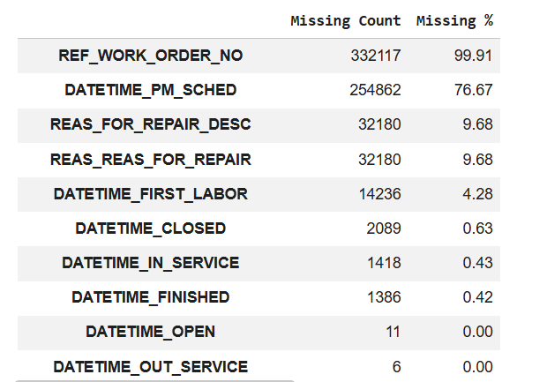
The data-quality audit turned up invalid negative values in cost and labor measures. Negative TOTAL_COST values (48 records) were set to missing and those rows removed, since total cost is central to the analysis. Negative LABOR_COST, PARTS_COST, COMML_COST and LABOR_HOURS values were also treated as invalid. No exact duplicate rows were found, and REF_WORK_ORDER_NO was dropped because roughly 99.9% of its values were missing.
Feature engineering centered on timing. TOTAL_DOWNTIME_HOURS combines user and shop downtime, while historical equipment features such as EQUIP_PRIOR_WO_COUNT and EQUIP_PRIOR_AVG_COST were built from prior records. Predictive models leave out variables that only become known once maintenance is underway or finished especially LABOR_HOURS and the direct components of the HIGH_IMPACT target so the predictive question matches the real prioritization decision.

3. Exploratory Data Analysis and Definition of Operational Impact

Question answered | How variable are maintenance cost and downtime, and do they represent the same operational problem?
Why this method? | EDA is used to understand distributions, skewness, outliers and relationships before formal statistical testing.

Both cost and downtime are strongly right-skewed. Mean maintenance cost sits at $563.82 against a median of $182.62; mean downtime is 388.52 hours against a median of 34.56 hours. The long upper tails show that a relatively small set of work orders drives a disproportionate share of the burden.

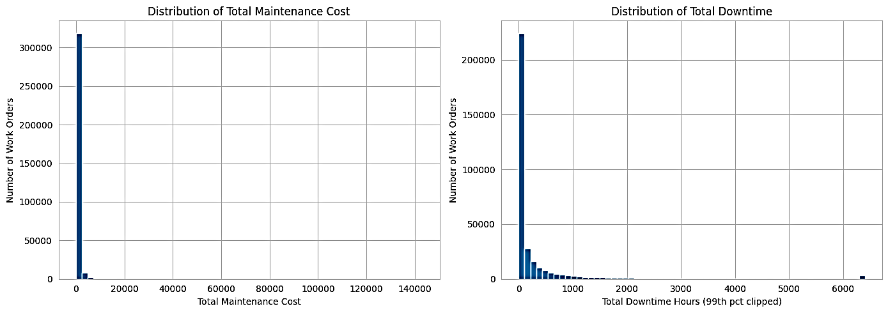
Figure 1. Distribution of total maintenance cost and total downtime (notebook output).

The Pearson correlation between total cost and downtime is only 0.086, so expensive work orders aren't necessarily the ones causing the most downtime. REPAIR orders are also more demanding than PM work: mean cost is $670.44 for REPAIR versus $213.34 for PM.
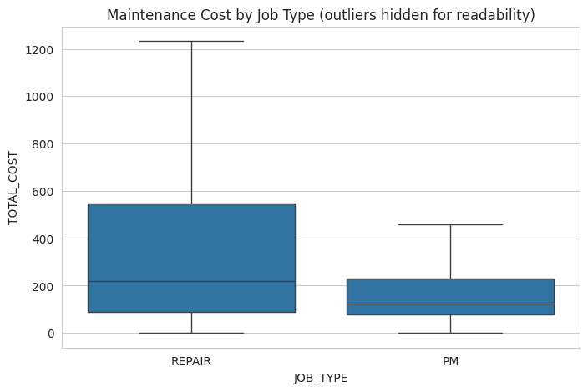
Figure 2. Maintenance cost by job type; extreme outliers hidden for readability (notebook output).

Equipment-Level Cost Concentration
Question answered:
Is maintenance expenditure concentrated among a relatively small proportion of equipment units?
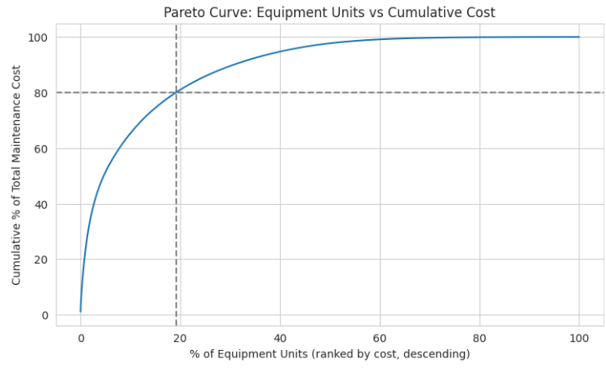
Finding: the Pareto analysis shows 19.1% of equipment units account for 80% of total maintenance cost a real concentration of spend in a small slice of the fleet. Prioritization should weigh recurring equipment-level burden, not just individual work-order risk.

Answer:
Maintenance cost is heavily concentrated at the equipment level. Roughly 19.1% of equipment units generate 80% of total maintenance spend, which points to an opportunity to flag persistently high-cost assets for closer monitoring, preventive action, or replacement.

3.1 Defining HIGH_IMPACT

Question answered | How should operational impact be represented for classification?
Why this method? | A combined binary target captures both financial impact and availability impact rather than treating cost alone as the definition of importance.

Code 1. HIGH_IMPACT construction:
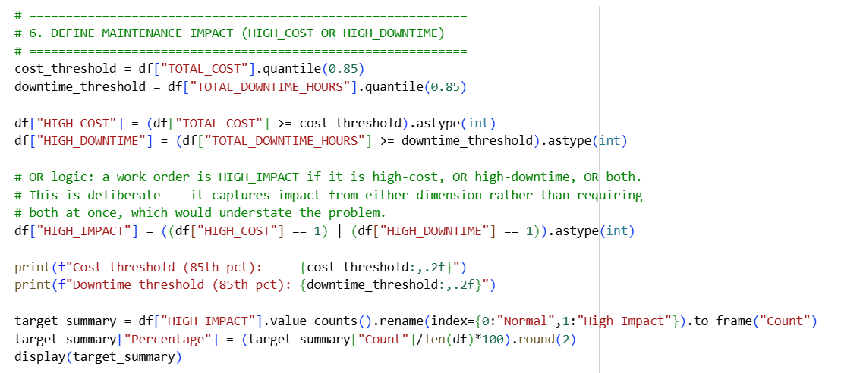

HIGH_IMPACT flags work orders with unusually high financial or operational impact. A work order is classified as high impact if its total cost exceeded $771.77 or its downtime exceeded 475.25 hours — the 85th-percentile thresholds for each. This rule flags 84,123 work orders (25.31%) as high impact.

The OR rule was used because cost reflects financial burden, while downtime reflects operational disruption, and the two are only weakly correlated (r ≈ 0.086). Only 18.5% of high-impact cases exceeded both thresholds, which confirms they capture different dimensions of impact. The 85th percentile is an analytical cutoff rather than an organization-defined standard and should be validated with fleet managers before it's used operationally.
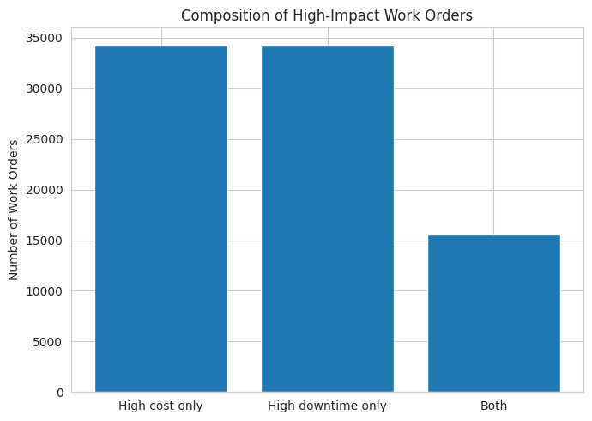
Figure 3. Composition of high-impact work orders (notebook output).

4. What Characterizes High-Impact Maintenance? (Q1)

4.1 Independent-Samples t-Test

Question answered | Do normal and high-impact work orders differ on important continuous operational characteristics?
Why this method? | HIGH_IMPACT creates two independent groups and the compared measures are continuous. A Welch independent-samples t-test compares their means; Cohen's d is added because the large sample can make trivial differences statistically significant.

Hypotheses: H0 - the mean operational measure is equal between Normal and High-Impact groups.
H1 - the means differ. Significance level: alpha = 0.05.

Code 2. Representative t-test logic
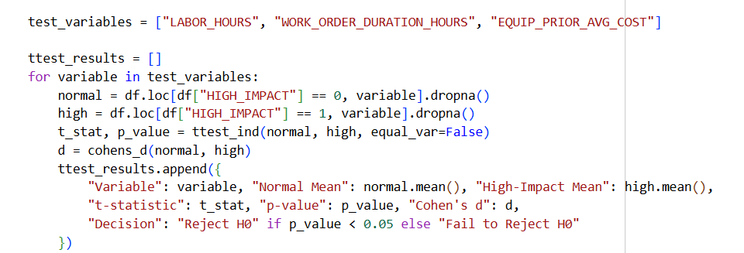

Variable | Normal mean | High-impact mean | p-value | Effect size
LABOR_HOURS | 1.611 | 8.668 | <0.001 | Cohen's d = 0.712
WORK_ORDER_DURATION_HOURS | 1,837.17 | 3,009.61 | <0.001 | d = 0.292
EQUIP_PRIOR_AVG_COST | $489.60 | $645.86 | <0.001 | d = 0.241

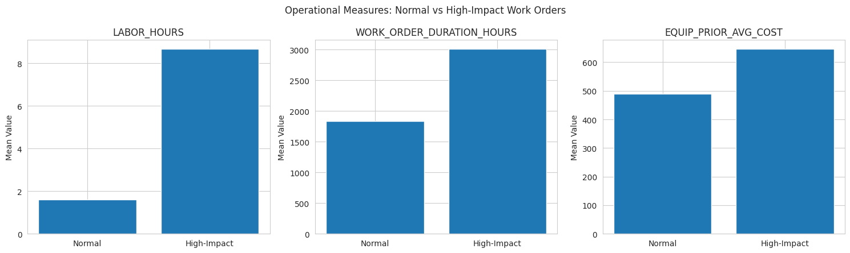
Figure 4. Operational measures: Normal versus High-Impact work orders (notebook output).

Answer to Q1:
Normal and high-impact work orders look operationally different. High-impact jobs need far more labor hours, run longer, and involve equipment with a costlier maintenance history. Job type matters too — REPAIR orders carry a noticeably higher high-impact rate than PM work. These are real signals of operational impact in maintenance characteristics and equipment history, though variables observed during maintenance are better treated as diagnostic than early-prediction inputs.

4.2 Chi-Square: Job Type and High Impact

Question answered | Are REPAIR work orders more likely to be high impact than PM work orders?
Why this method? | JOB_TYPE and HIGH_IMPACT are categorical variables, so a Chi-square test of independence is appropriate. Cramer's V measures the strength of association.

Hypotheses: H0 - JOB_TYPE and HIGH_IMPACT are independent.
H1 - they are associated.
Statistic | Result
Chi-square | 11,185.863
Degrees of freedom | 1
p-value | <0.001
Cramer's V | 0.1835
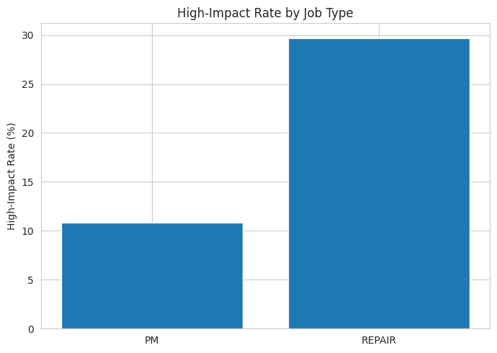
Figure 5. High-impact rate by job type (notebook output).

The null hypothesis is rejected: REPAIR jobs are substantially more likely to be high impact than PM jobs. The effect is meaningful, though not overwhelming job type works as a useful signal, not a complete prioritization rule.

5. Are Existing Priorities Aligned with Operational Impact? (Q2) –

One-Way ANOVA

Question answered | Do assigned maintenance priority codes meaningfully distinguish work orders according to actual operational impact, measured through total maintenance cost and total downtime?
Why this method? | One-way ANOVA was used to test whether mean cost and downtime differ across priority codes, while eta-squared (η²) measured the practical size of these differences.

Hypotheses: H0 - mean cost/downtime is equal across priority codes.
H1 - at least one priority group differs.

Code 3. ANOVA and effect-size logic
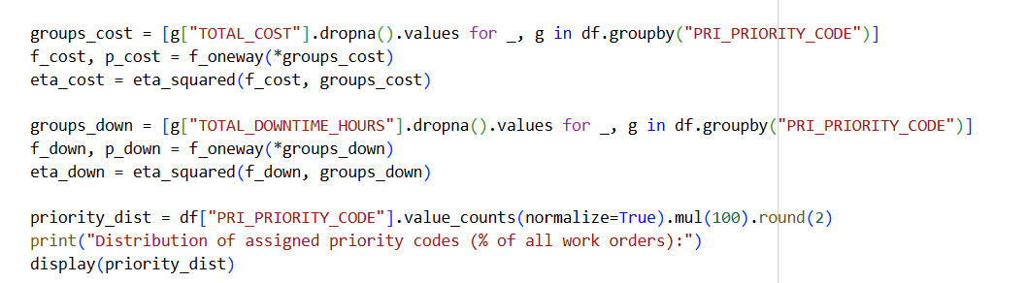

Since p < 0.001, the null hypothesis is rejected for both outcomes mean cost and downtime do differ statistically across priority groups. But the effect sizes are tiny: priority code explains only about 0.14% of the variation in maintenance cost and 0.23% of the variation in downtime.
Statistical and practical significance aren't the same thing here. With over 300,000 work orders, even trivial differences produce very significant p-values. The η² values are the more honest measure of practical utility, and they suggest priority code explains very little of the actual variation in operational impact.

Outcome | F-statistic | p-value | eta-squared | Interpretation
TOTAL_COST | 152.57 | 8.15 x 10^-99 | 0.0014 | Significant; practically tiny
TOTAL_DOWNTIME_HOURS | 250.90 | 1.20 x 10^-162 | 0.0023 | Significant; practically tiny

Priority Code 3 accounts for 98.31% of all work orders (Code 1: 0.82%, Code 2: 0.53%, Code 4: 0.34%). The ANOVA p-values reject H0, but the effect sizes show priority explains well under 1% of the variation in either outcome. With a dataset this large, statistical significance alone doesn't prove useful triage.

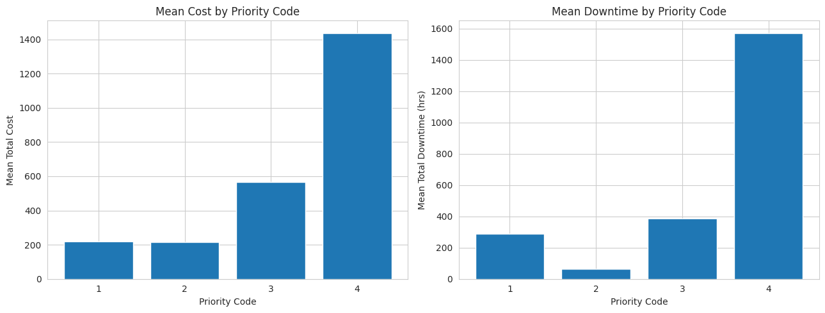
Figure 6. Mean maintenance cost and downtime by assigned priority code (notebook output).

There is a statistical association between existing priorities and operational impact, but it isn't strong enough to differentiate work orders practically. The effect sizes for cost (η2 = 0.0014) and downtime (η2 = 0.0023) are small, and with 98.31% of work orders sitting in Priority Code 3, the current structure explains only a sliver of actual variation. The clearest opportunity is more differentiation within Priority Code 3 using historical and risk-based information.

Business Implication
These results support adding a data-driven risk-screening layer rather than replacing the current system. Work orders within Priority Code 3, for instance, could be further distinguished by equipment history, job type, past maintenance behaviour, department history and predicted high-impact risk surfacing consequential cases earlier while leaving the existing priority structure and managerial judgment intact.

6. Are Operational Segments Hidden Within Current Priorities? (Q3) –

K-Means Clustering

Question answered | Do naturally occurring maintenance profiles exist that the current priority system fails to distinguish?
Why this method? | K-Means is an unsupervised segmentation method. It groups work orders by operational similarity without using existing priority labels, providing an independent check of the priority-alignment conclusion.

Clustering used five variables: total cost, total downtime, labor hours, work-order duration, and scheduling delay. Min-max scaling kept larger-valued variables from dominating the result. The elbow analysis pointed to K=4 as a practical, interpretable solution, revealing four distinct profiles: routine, downtime-heavy, high-cost/labor-intensive, and scheduling-delay dominated.
Code 4. K-Means setup 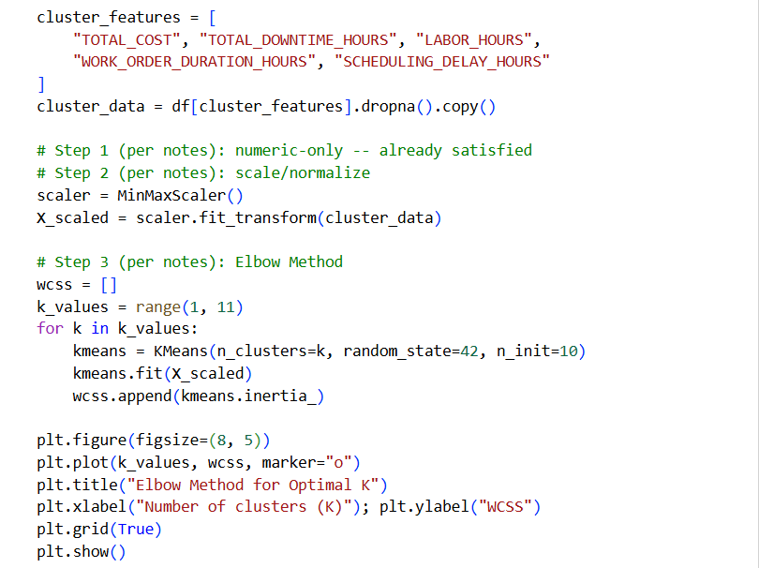
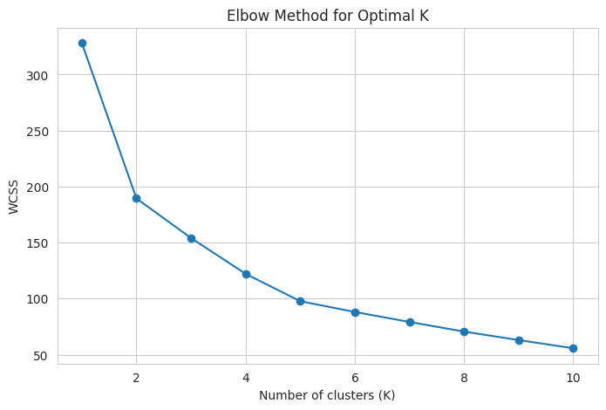
Figure 7. Elbow method for selection of K

Cluster | Avg. cost | Avg. downtime | Avg. labor hrs | Avg. WO duration | Count | Profile
0 | $172.27 | 171.56 | 1.44 | 513.46 | 31,164 | Routine / low burden
1 | $164.15 | 709.86 | 1.43 | 6,924.68 | 3,579 | Long-duration / downtime-heavy
2 | $1,261.62 | 452.89 | 8.79 | 853.34 | 1,760 | High-cost / labor-intensive
3 | $81.75 | 318.12 | 0.79 | 645.59 | 577 | Scheduling-delay dominated

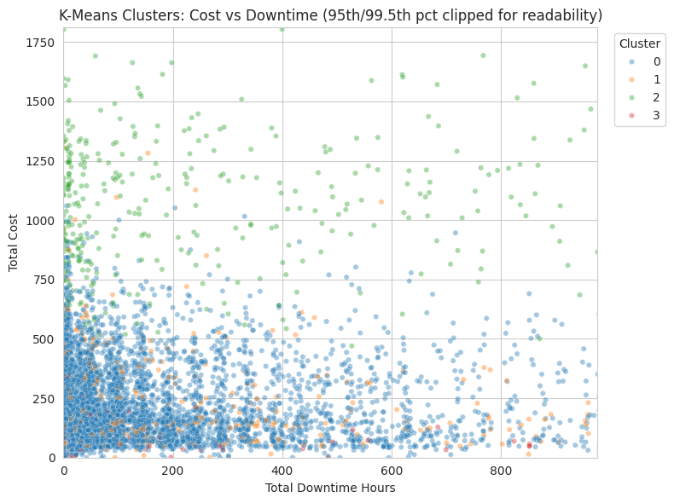
Figure 8. K-Means clusters plotted on cost versus downtime; axes clipped for readability (notebook output).

Cluster 2 the highest-cost, most labor-intensive segment is still 98.7% Priority Code 3.
The other clusters look much the same, overwhelmingly Code 3.
Answer to Q3:
Operationally distinct maintenance profiles clearly exist, but the current priority assignment doesn't separate them in any meaningful way.

7. What Drives Maintenance Cost? (Q4A) - Multiple Linear Regression

Question answered | How much of maintenance cost can be explained using information available early enough to support prioritization?
Why this method? | TOTAL_COST is continuous and multiple explanatory variables may act simultaneously. MLR estimates their partial associations while allowing diagnostics for multicollinearity and model assumptions.

Two MLR specifications were evaluated to distinguish retrospective cost explanation from early prediction. A diagnostic model using information generated during the maintenance process achieved a Test R² of 0.834, showing that realized operational information can explain maintenance cost well. However, because this model includes post-hoc information such as labor hours, it is not suitable for early prioritization.
The early-prioritization model therefore uses only information available before or at work-order creation: PRI_PRIORITY_CODE, EQUIP_PRIOR_AVG_COST, EQUIP_PRIOR_WO_COUNT, JOB_TYPE_REPAIR, and a train-only encoding of DEPT_AVG_COST.

Diagnostic MLR : Retrospective Explanation:
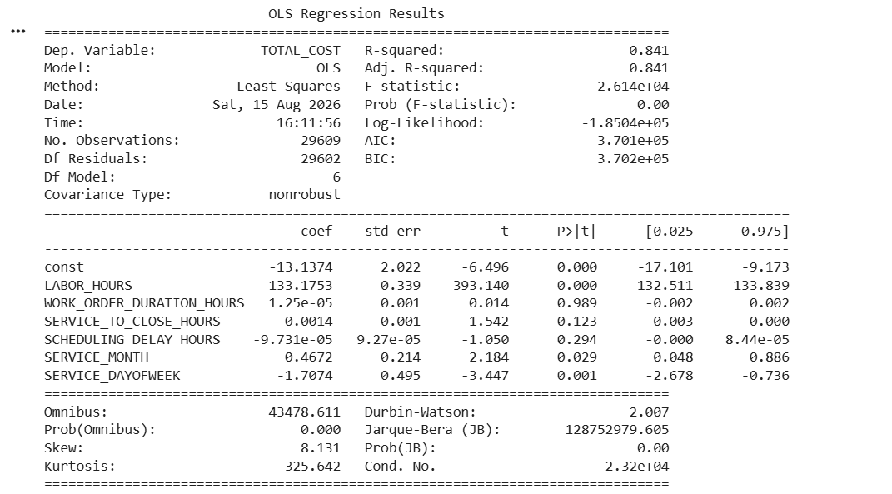

Early-Prioritization MLR : Decision-Support Model:
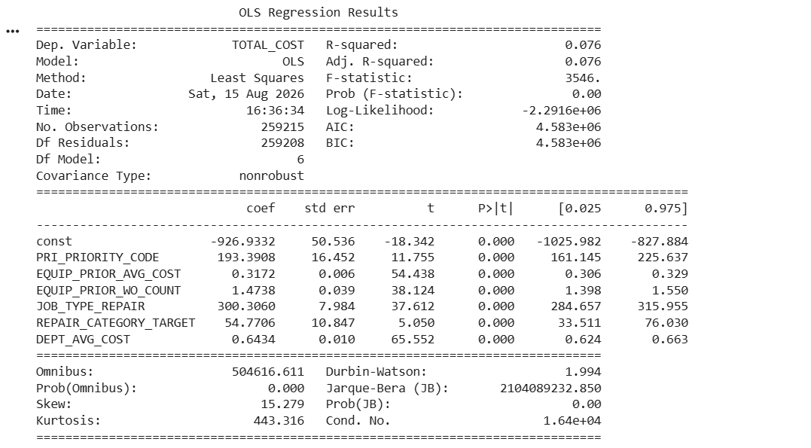

Model | Test R² | Purpose
Diagnostic MLR | 0.8340 | Retrospective cost explanation
Early-Prioritization MLR | 0.0725 | Early cost prediction

REPAIR_CATEGORY_TARGET was initially included but removed after VIF diagnostics identified problematic collinearity. Maximum VIF fell from 16.50 to 5.85, while Test R² remained almost unchanged (0.0723 to 0.0725), improving interpretability without sacrificing model fit.
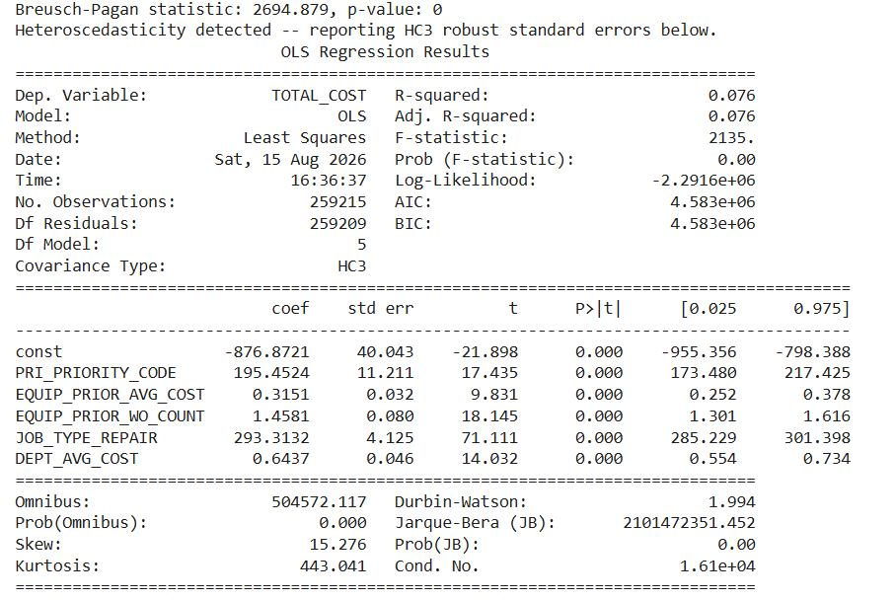

Model | Max VIF | Test R-squared | Purpose
Initial early model | 16.50 | 0.0723 | Initial specification
Improved VIF-resolved model | 5.85 | 0.0725 | Selected early-prioritization model

The Breusch-Pagan test (statistic 2,694.879; p < 0.001) points to heteroscedasticity, so HC3 robust standard errors were used for inference. Residual normality is also rejected, in line with the extreme right-skew in cost. A log transformation improved the distributional shape but performed worse once retransformed back to dollars (R-squared = -0.1265), so the raw-scale model was kept, since the business question is about dollar-scale cost.
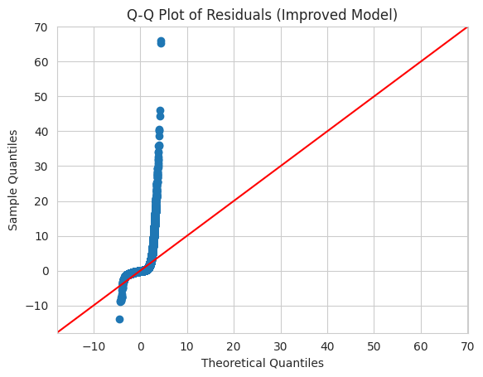
Figure 9. Q-Q plot of residuals for the improved MLR model (notebook output).
The early model provides directional cost signals. Prior equipment cost, maintenance frequency, job type, department history and recorded priority are associated with expected maintenance cost after controlling for the other model variables. These relationships represent associations, not causal effects.

Predictor | Coefficient (approx.) | Interpretation
PRI_PRIORITY_CODE | +195.45 | Higher priority codes are associated with higher expected maintenance costs, after accounting for other factors.
EQUIP_PRIOR_AVG_COST | +0.315 per $1 | Historical equipment cost carries forward-looking cost signal.
EQUIP_PRIOR_WO_COUNT | +1.458 per prior WO | Repeated maintenance history is associated with higher current cost.
JOB_TYPE_REPAIR | +$293.31 | Repair jobs are associated with higher cost than the reference job type.
DEPT_AVG_COST | +0.644 per $1 | Department history adds cost signal.

Answer to Q4A
Maintenance cost can be explained well retrospectively (Diagnostic R² = 0.834), but early prediction remains limited (Early Model R² = 0.0725). Therefore, early known information is more useful for understanding cost risk and supporting prioritization than for accurately forecasting the exact cost of individual work orders.

8. Can High-Impact Work Orders Be Identified Early? (Q4B) - Logistic Regression
Question answered | Can information available during prioritization identify work orders likely to become HIGH_IMPACT?
Why this method? | HIGH_IMPACT is binary, so logistic regression is appropriate for estimating high-impact probability. A stratified train/test split preserves class proportions, and target-defining cost/downtime variables are excluded to prevent leakage.

Model Specification
The model uses early-known and historically derived information including job type, existing priority, prior equipment average cost, prior work-order frequency and department-level maintenance history. These predictors were selected to test whether historical maintenance behaviour and work-order characteristics provide an early indication of future operational impact.

Model Performance
The model achieved a ROC-AUC of approximately 0.641, indicating modest ability to distinguish high-impact from normal work orders. At the default 0.50 threshold, recall was only 1.10%, meaning that almost all high-impact cases were missed despite an accuracy of 75.20%. This highlights why accuracy alone is misleading for the imbalanced target.

Metric | Cutoff 0.50 | Selected cutoff 0.25
Accuracy | 0.7520 | Lower due to more reviews
Precision - High Impact | 0.4986 | 0.3162
Recall - High Impact | 0.0110 | 0.7059
F1 - High Impact | 0.0216 | Improved materially
ROC-AUC | 0.6418 | 0.6414
False-positive rate | ~0.3% | 50.33%
Share flagged | Very small | 55.4%

Code 5. Logistic model and operating threshold

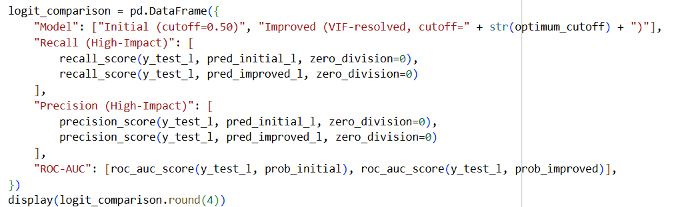

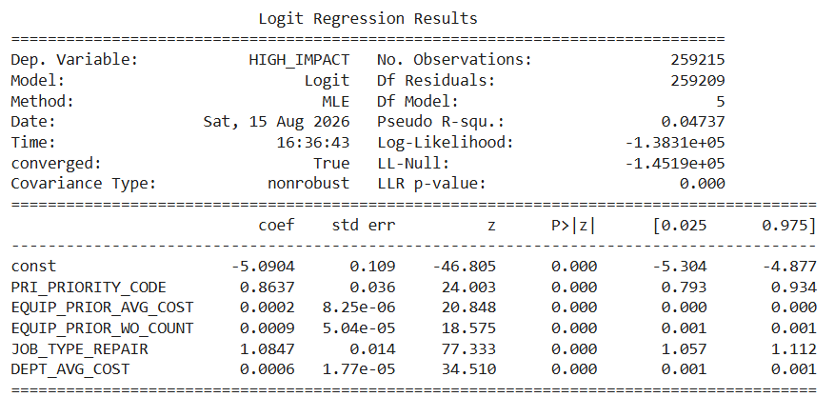

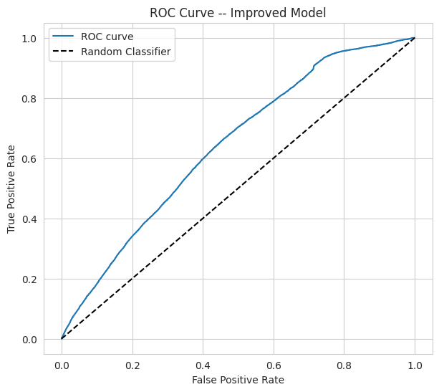
Figure 10. ROC curve for the early high-impact classification model (notebook output)

Threshold Analysis
Lowering the threshold to 0.25 increases recall to 70.59%, substantially improving detection of high-impact work orders. The trade-off is material: precision falls to 31.62%, the false-positive rate rises to 50.33%, and 55.4% of all work orders would be flagged for review. Changing the threshold does not strengthen the underlying model; it changes the operating trade-off.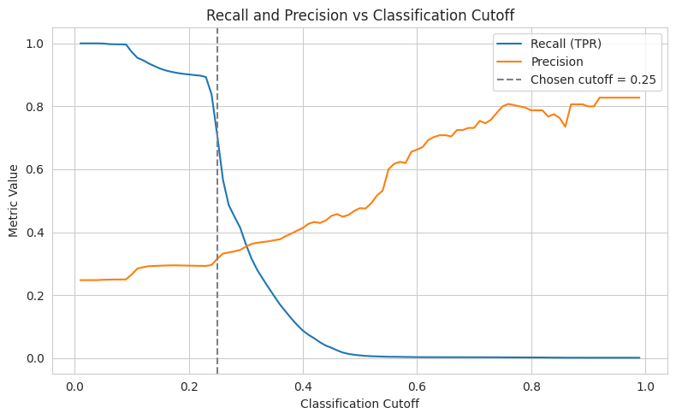
Figure 11. Recall and precision across classification cutoffs; selected statistical cutoff = 0.25 (notebook output).
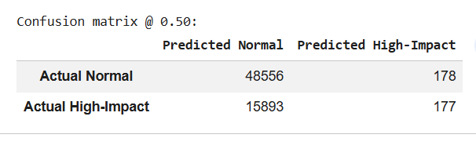
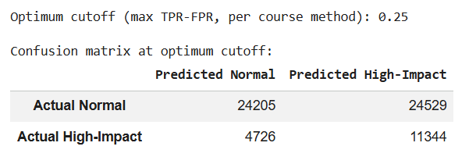

Predictor Interpretation
Repair work is the strongest early signal: JOB_TYPE_REPAIR has an odds ratio of approximately 2.96, meaning repair work has about 2.96 times the odds of high-impact status relative to the reference job type, holding other model variables constant. Existing priority also carries predictive information, while prior equipment cost, prior work-order frequency and department history provide smaller incremental risk signals. These are associations, not causal effects.
Model Fit and Interpretation
McFadden pseudo R² is 0.0474. Unlike R² in linear regression, pseudo R² should not be interpreted as the percentage of variation explained. For this classification problem, ROC-AUC, recall, precision and false-positive workload provide more decision-relevant measures of model usefulness.
The model's ROC-AUC of approximately 0.641 confirms that predictive separation is useful but limited. It should therefore not be treated as a deployment-ready automated classifier.

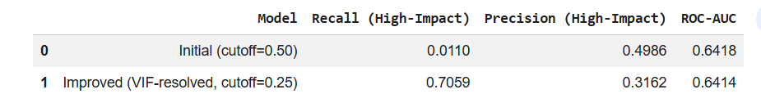

Predictor | Odds Ratio | Interpretation
JOB_TYPE_REPAIR | 2.96 | Strongest early risk signal
PRI_PRIORITY_CODE | 2.37 | Higher codes associated with higher high-impact odds
Prior equipment cost | Small incremental effect | Historical cost contributes risk information
Prior WO count | Small incremental effect | Maintenance frequency adds risk signal
Department history | Small incremental effect | Department-level history adds risk signal

ANSWER TO Q4B:

High-impact work orders can be identified early with modest predictive capability. The model achieves ROC-AUC ≈ 0.641 and, at the 0.25 screening threshold, identifies 70.59% of actual high-impact cases. However, 55.4% of all work orders would require review. The model is therefore best used as an early risk-screening and decision-support layer rather than as an automated replacement for existing priorities or managerial judgement.

9. Does Predicted Risk Match Existing Priority? - Chi-Square Comparison

Question answered | Are model-flagged high-impact work orders already being captured by non-default priority codes?
Why this method? | Comparing predicted risk with actual assigned priority directly reconnects the predictive model to the original business question about priority alignment.

Among predicted high-impact work orders, 99.36% still carry Priority Code 3, and only 0.64% carry Code 4; predicted Normal orders are 97.18% Code 3. The association is statistically significant (Chi-square = 1,187.54, p < 0.001), but the dominant default code swamps any practical separation.

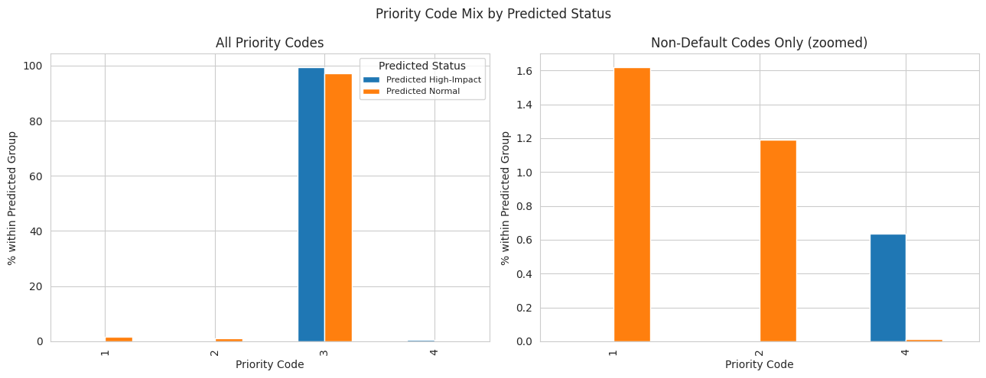
Figure 12. Priority-code mix by predicted high-impact status (notebook output).
That supports the core conclusion: the predictive model isn't just reproducing an already well-differentiated priority system. It surfaces risk inside the same dominant category exactly where a supplemental screening layer could add value.

10. Integrated Findings and Recommendations

Evidence | What it means for the business
98.31% of work orders are Priority 3 | Current coding offers little routine differentiation.
ANOVA eta-squared < 0.003 | Statistical significance does not translate into meaningful practical separation.
Distinct K-Means profiles remain mostly Priority 3 | Operationally different jobs are hidden inside the same code.
Early MLR R-squared = 0.0725 | Exact cost forecasting from intake information is difficult.
Logistic AUC ~0.641; recall 70.59% at 0.25 | Historical data provides a modest screening signal, with a substantial review-workload trade-off.

Recommendations

1. Establish an Equipment Risk Watchlist
Track equipment with frequent work orders, high historical maintenance costs, or repeated high-impact events. This helps managers flag assets that may need closer monitoring, preventive action, or a replacement decision.

2. Introduce Data-Assisted Risk Screening
Use information already available at work-order creation — job type, equipment history, department history, predicted high-impact risk — alongside the existing priority code. The model should flag cases for review, not automatically change priorities.

3. Focus on Priority Code 3
With 98.31% of work orders under Priority Code 3, that's where better differentiation matters most. Risk screening can separate routine cases from potentially high-impact ones without redesigning the whole priority system.

4. Choose the Threshold Based on Operational Capacity
The 0.25 threshold catches 70.59% of high-impact cases but flags 55.4% of all work orders. The final threshold should reflect the cost of missing high-impact cases against the team's capacity to review additional alerts.

5. Pilot Before Full Deployment
Start by showing the risk score alongside the existing priority code as a decision-support tool. Monitor model performance, false positives, review workload, and manager feedback before considering wider rollout.

Proposed Risk-Based Maintenance Triage Framework
The analytical findings point to one clear opportunity: not replacing the existing maintenance priority system, but adding a risk-screening layer within it. This matters most for Priority Code 3, which holds roughly 98.31% of work orders and, with it, maintenance cases with widely different operational characteristics.
At work-order creation, information already on hand or derived from historical records can be combined to estimate the probability that a work order turns high impact. That risk signal can then flag cases needing additional managerial attention.

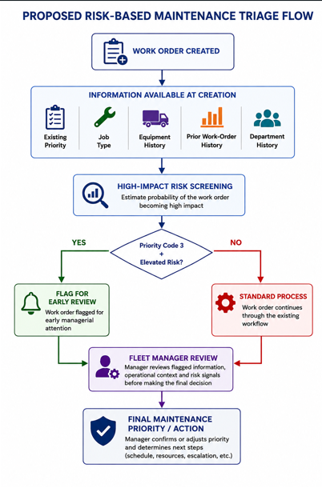

11. Limitations and Future Scope

HIGH_IMPACT relies on an analytical 85th-percentile cutoff and needs business validation. Repeated equipment records may affect independence, while skewed cost data and model diagnostics limit MLR performance. The logistic model offers only modest discrimination, and the selected threshold could create a heavy review workload. K-Means may also stay sensitive to extreme values. Overall, the results point to associations and predictive signals, not causality.
Future work should bring in vehicle criticality, utilization, and service-level impact, along with richer equipment data; validate the HIGH_IMPACT definition with fleet managers; and choose prediction thresholds based on the real business costs of false positives versus missed high-impact cases.

12. Conclusion
This study asked whether the current fleet maintenance priority system reflects actual operational impact, and where data-driven prioritization could improve decision-making. The findings show that existing priorities are related to operational impact, but they don't differentiate work orders effectively in practice.
The strongest evidence is the concentration of 98.31% of work orders in Priority Code 3. Cost and downtime differed significantly across priority groups, but the effect sizes were tiny (η² = 0.0014 for cost and η² = 0.0023 for downtime) priority code explains very little of the actual variation. K-Means reinforced this by surfacing distinct profiles hidden within the current structure: 98.7% of the high-cost, labour-intensive cluster was still Priority Code 3.
The predictive models show where analytics can help and where it can't. Forecasting exact cost early is difficult: the leakage-controlled MLR explains only 7.25% of test-set cost variation. Logistic regression was more useful for risk, though moderate (ROC-AUC ≈ 0.641). At 0.25, it caught about 70.6% of actual high-impact work orders, with lower precision (31.6%) and a review burden of 55.4% of all work orders. The model suits screening better than automated priority assignment.
The greatest opportunity lies within Priority Code 3. Rather than treating this large group of work orders as one block, fleet managers can draw on additional information job type, equipment history, prior maintenance behaviour, department history, predicted high-impact risk to flag cases that need earlier attention.
Overall, the findings support a hybrid risk-based triage approach. The existing priority system stays in place, while analytics adds an early-warning signal to help managers spot potentially high-impact work orders. This sharpens differentiation without displacing managerial judgement, making maintenance decisions more focused and risk-sensitive.

Appendix: Technical Evidence
The submitted notebook remains the full reproducibility record. This report includes only representative code extracts and the notebook figures needed to explain the analytical logic; full model summaries, VIF tables, confusion matrices, threshold sweeps and additional diagnostics stay in the notebook.
Technique | Question answered | Key final result
t-test | Do high-impact and normal jobs differ? | Labor hours show the largest standardized difference, d = 0.712.
Chi-square | Is job type associated with high impact? | chi-square = 11,185.863; Cramer's V = 0.1835.
ANOVA | Do priority codes differentiate impact? | Significant p-values but eta-squared = 0.0014 / 0.0023.
K-Means | Do distinct operational profiles exist? | Four interpretable clusters; high-cost cluster is 98.7% Priority 3.
MLR | Can early-known variables explain cost? | Selected model Test R-squared = 0.0725; HC3 inference used.
Logistic | Can high-impact jobs be screened early? | ROC-AUC = 0.6414; recall = 70.59% at cutoff 0.25.

